

SET – 1.2

Name:- ………………..…………………………………………… Roll No:
Subject: - Science Grade: III Div.
Time:- 1 Hour Date : 21.06.2025
Obtained Marks
Invigilator’s Sign Total Marks 20 Evaluator’s Sign

Subject – Science
Q.1) Fill in the blanks with correct options. [M2]
1] Animals are ________________things. [living/ Non-living]
2] Plants can feel ___________________ to grow. [darkness/ sunlight]
3] Living things are _________________. [not alive /alive]
4] Living things need to _____________air to stay alive. [breathe/grow]
Q.2) Circle the odd one out in each of the following. [M2]
1]Tiger, Dog, Book, Plant
2] Bag, Tree, Table, Stone
3] Sun, House, Moon, Mountain,
4] Horse, River, Dog, Plant
Q.3 Classify the things. [M2]
Lion, Man, Shoes, Computer

Living things: - ____________________________________
Non -living Things: - ________________________________
Q.4) Tick ($√)$ the correct answer. [M2]
1] All of these are living except------------.
A] Frog B] Tortoise C] Snake D] Window
2] Which of the following is natural thing?
A] Sun B] Bag C] Pen D] Car
3] Which of these is not man –made thing?
A] Socks C] Mountain C] Watch D] Mobile
4] Which of these is non-living thing?
A] Camel B] Donkey C] Laptop D] Rose
Q.5) Define the following. [Any 2] [M2]
A] Living Things: -

B] Man Made Things: -

C] Natural Things: -

Q.6) Answer the following. [Any 3] [M3]
1] Write names of any two natural things.

2] Write names of any two living things.

3] Which part does plants use to breathe?

4] Which body organ does fish use to breathe?

Q.6) Answer the following. [Any 1] [M2]
1] What are the features of living things?

2] How natural things are different from man made things?
Q.7) Identify the things and write its type. [Natural/ Man-Made] [M2]

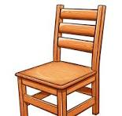
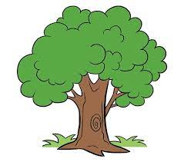

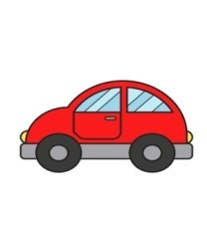
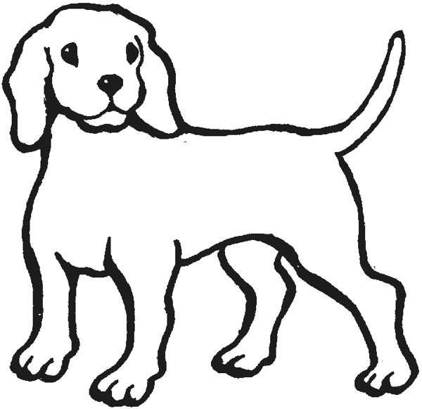

Q.8) Draw any one natural thing. [M2]

Q.9) Complete the concept map given below. [M1]
TYPES OF THINGS

Ex.
Ex.
NON-LIVING THINGS
LIVING THINGS

